# Heap Organized Tables

## Task 1 – Heap Understanding

## 

## Task 2 – Understanding Low level of data abstraction: Heap Table Segments

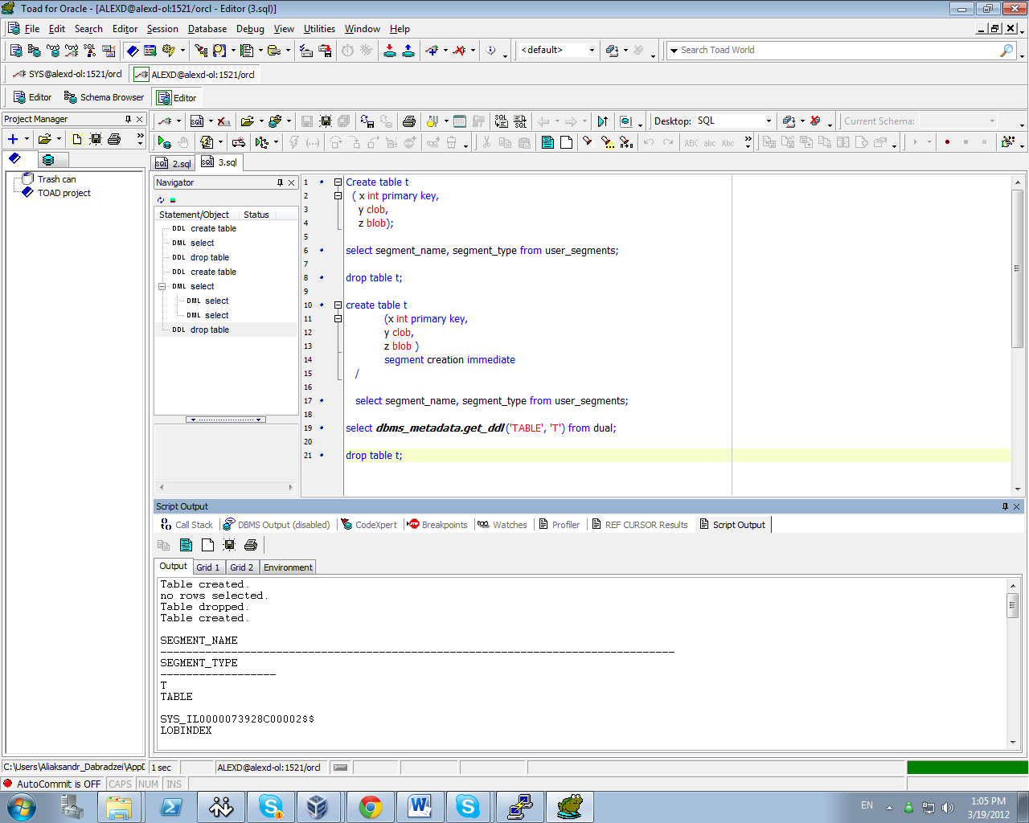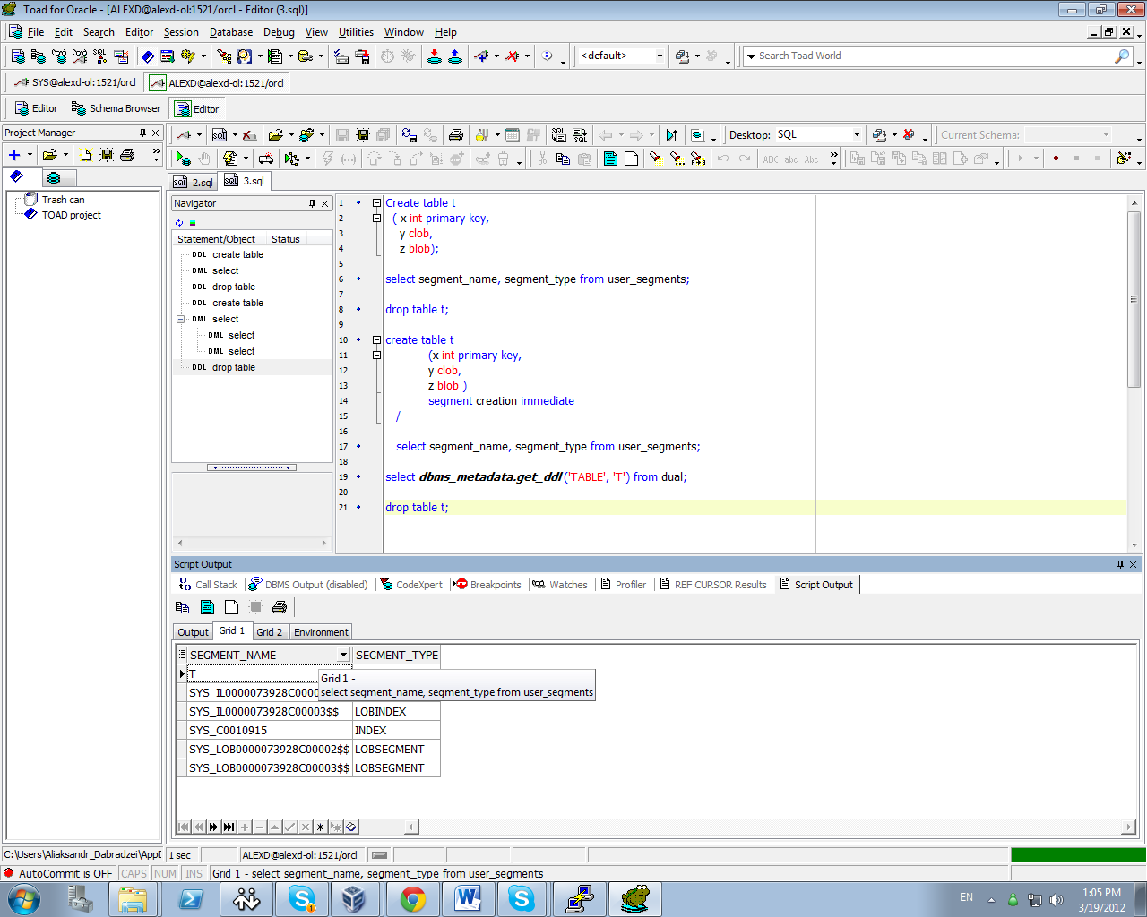

# Index Organized Tables

## Task 3: Compare performance of using IOT tables

Calculate Statistic:

begin

dbms_stats.gather_table_stats( user, 'EMP', cascade=>true );

end;

exec dbms_stats.gather_table_stats( $username$, 'HEAP_ADDRESSES' );

exec dbms_stats.gather_table_stats( $username$, 'IOT_ADDRESSES' );

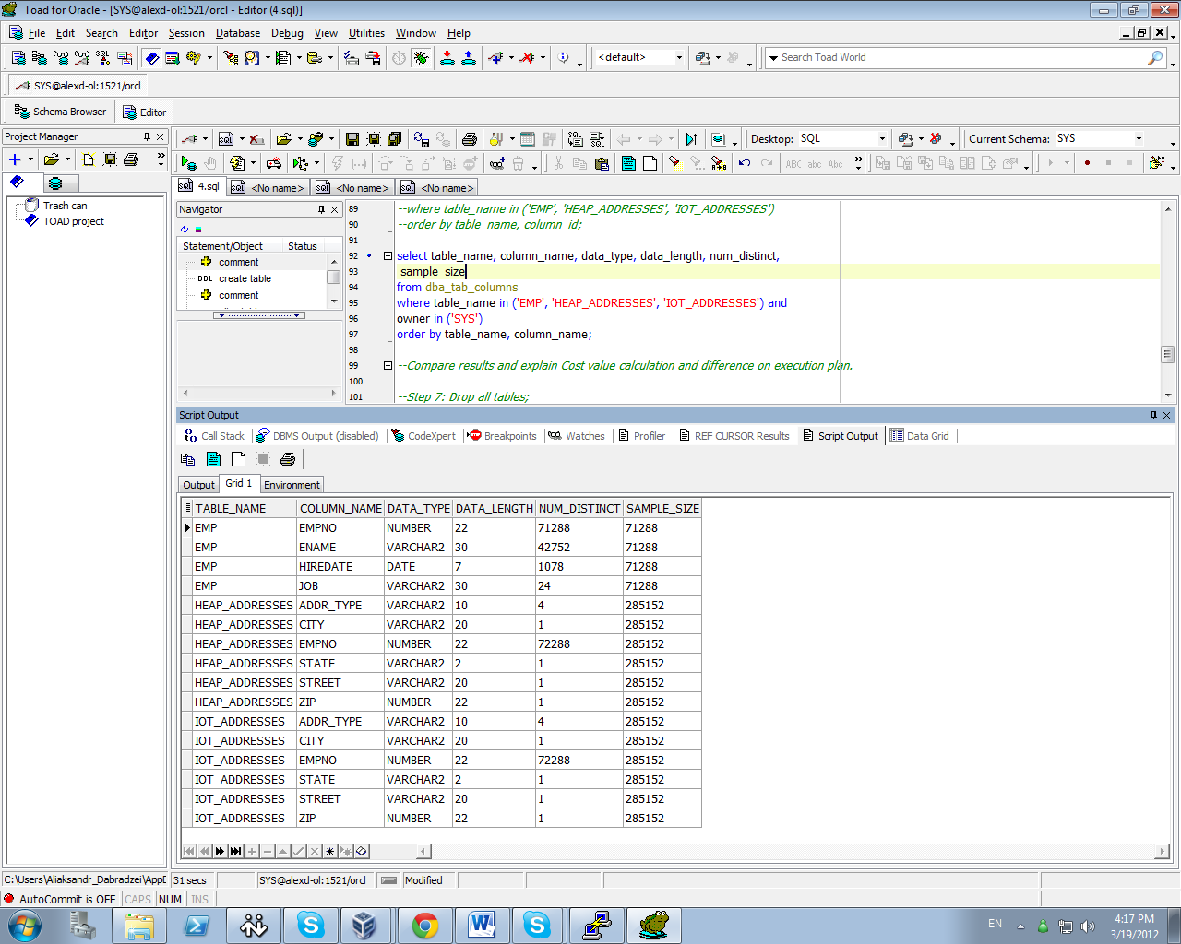

Compare Trace and Performance:

Explain 1:

SELECT *

FROM emp ,

heap_addresses

WHERE emp.empno = heap_addresses.empno

AND emp.empno = 42;

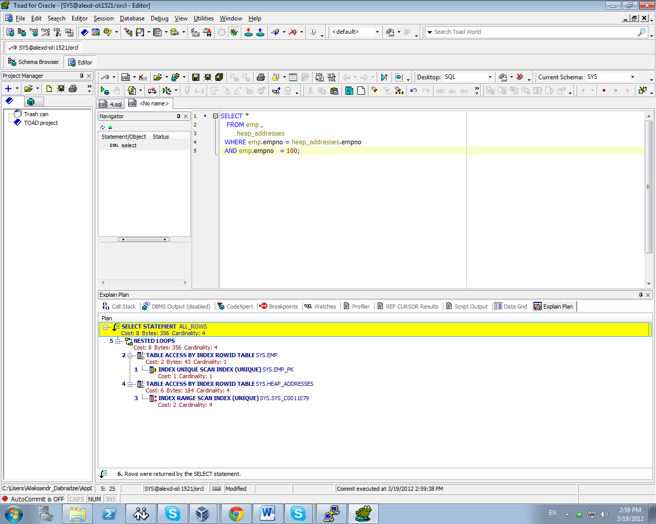

Explain 2:

SELECT *

FROM emp ,

iot_addresses

WHERE emp.empno = iot_addresses.empno

AND emp.empno = 42;

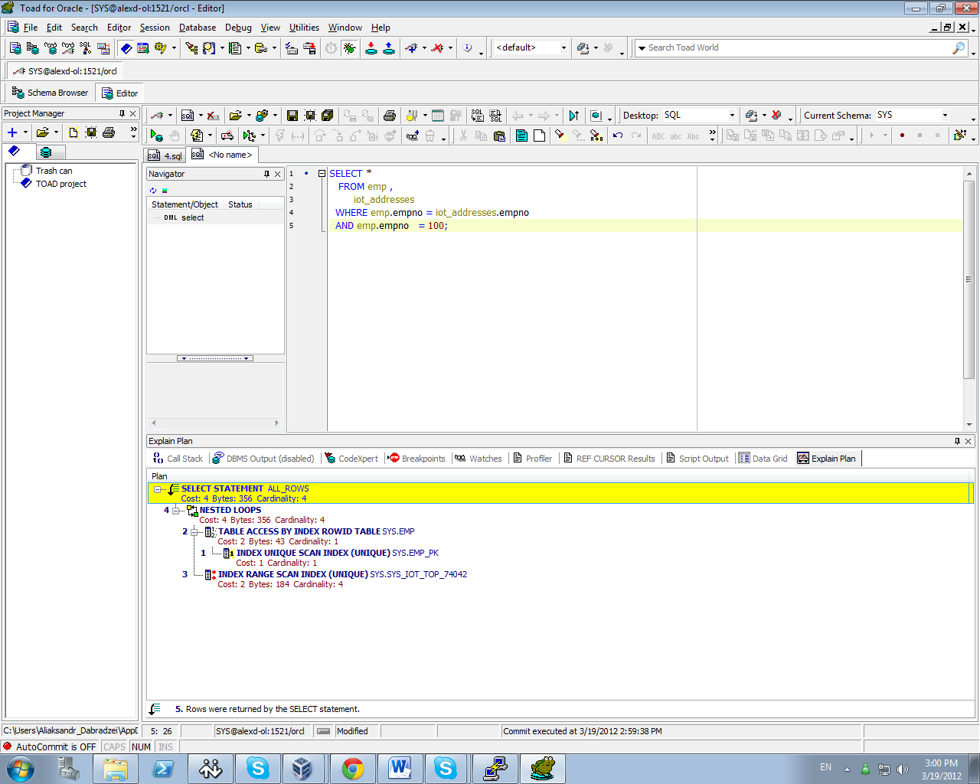

Compare results and explain Cost value calculation and difference on execution plan.

Expected Heap table cost > IOT table cost

Prepare screenshots and write explanation why cost is different.

Both tables are same, but IOT table has less cost than heap, it store rows in a B-tree index structure that is logically sorted in primary key(empno) order. Unlike normal primary key indexes(heap orginised table), which store only the columns included in it definition, IOT indexes store all the columns of the table.

## Task 4: Analyses Cluster Storage by Blocks

**Task Results:**

Expected All data have to be stored on the same block.

Prepare screenshots and write explanation why data storage look like on select.

Describe advantages of this type of storage.

Clusters are groups of one or more tables, physically stored on the same database blocks, with all rows that share a common cluster key value being stored physically near each other. Many tables may be stored physically joined together. Normally, you would expect data from only one table to be found on a database block, but with clustered tables, data from many tables may be stored on the same block.

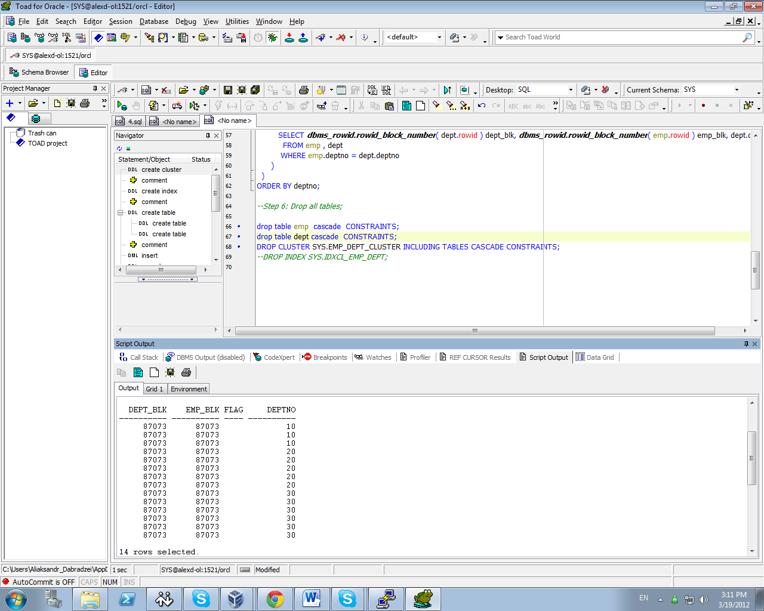

# Hash Clustered Tables

## Task 5: Analyses Cluster Storage by Blocks

These tables are similar to index clustered tables, but instead of using a B*Tree index to locate the data by cluster key, the hash cluster hashes the key to the cluster to arrive at the database block the data should be on. In a hash cluster, the data is the index (metaphorically speaking). These tables are appropriate for data that is read frequently via an equality comparison on the key.

